**Module on NMR of dynamic systems: practice for problems with numerical solutions**

1. The assembly of **X** and **Y** is in fast exchange. You can observe a proton on compound **X** move downfield upon addition of **Y**. Given the data below, what is the value of K11?

free = 1.3 ppm

bound = 3.3 ppm

Xt = 2 mM

Y­t = 2 mM

obs = 3.1 ppm

*X + Y 🡨🡪 XY*

*f11 = ∆∂obs / ∆∂max = 1.8 / 2 = 0.9 = [XY]/Xt*

*[XY] = 1.8 mM*

*Xt = [X] + [XY] = 2 mM,*

*[X] = 2 mM – 1.8 mM = 0.2 mM*

*Yt = [Y] + [XY] = 2 mM*

*[Y] = 2 mM – 1.8 mM = 0.2 mM*

*K11 = [XY]/[X][Y] = 0.0018 M / 0.0002 M • 0.0002 M = 45,000 M–1*

2. The NMR spectrum of a 1:1 host-guest complex (HG) is shown below. Signals for free and bound guest are labeled, along with their integrals.



Given the following concentrations, what is the value of K11?

Ht = 2.5 mM

Gt = 10 mM

*H + G 🡨🡪 HG*

*[G]/[HG] = 4*

*[G] = 4[HG]*

*Gt = [G] + [HG] = 4[HG] + [HG] = 5[HG] = 10 mM*

*[HG] = 2 mM, and therefore [G] = 8 mM*

*Ht = [H] + [HG] = 2.5 mM*

*[H] = 2.5 mM – 2 mM = 0.5 mM*

*Kassoc = [HG]/[H][G] = 0.002 M/.0005 M •.008 M = 500 M–1*

3. The NMR in question 2 was taken at 298 K on a 600 MHz NMR spectrometer. Can you set an upper limit on the rate of exchange between free and bound guest under these conditions?

*The peaks are well resolved and sharp, which means that the rate is probably >100-fold slower than the rate at the coalescence temperature (which must be somewhere above 298 K). We can calculate that rate at coalescence as our conservative upper limit.*

*k = π • ∆/(root 2)*

*∆ = (2.6 ppm – 0.7 ppm) * 600 MHz = 1140 Hz*

*k = π • 1140 s-1 / (root 2) = 2530 s–1*

4. The analysis of higher equilibria relies on familiar tools. Consider an elongated dimeric host (below, left) that forms from two resorcinarenes “R,” and binds two deuterated benzenes “B” in *p*-xylene solution:





a) What is the form of the equilibrium constant ?

* = [B2R2]/[B]2[R]2*

b) Define four of the possible stepwise association constants.

*K11 = [BR]/[B][R]*

*K21 = [B2R]/[BR][B]*

*K12 = [BR2]/[BR][R]*

*K22 = [B2R2]/[BR2][B]*

*Many are possible… the reactants and reagents should make sense for any single step on the way to B2R2. Note that there can be more than one stepwise K22 on the way to B2R2.*

c) What is the mass balance equation for the guest toluene?

*Bt = [B] + [B2] + [BR] + [BR2] + [B2R2] (You might also assume that B2 does not form under these conditions… why would benzene dimerize on its own in an aromatic solvent?)*

d) If Rt is 50-fold higher than Bt, how does that mass balance equation change?

*In the presence of huge excess of R, you can assume no free B or B2, so*

*Bt = [BR] + [BR2] + [B2R2]*

5. The NMR data shown below was obtained in order to analyze the 1:1 binding of Cl– to an anion receptor.

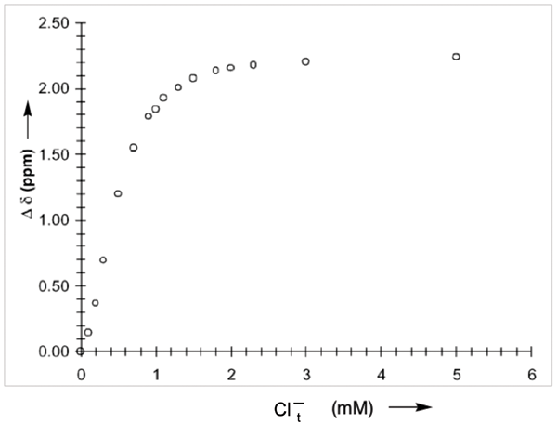

a) Describe how you would obtain a binding constant (K11) from this data *without using a non-linear curve-fitting algorithm*. Provide a detailed description that includes: the formula you would use for your analysis, what data would be plotted on each axis, the expected appearance of the resulting graph, and how you would obtain K11 from the resulting plot.

*For my answer, I’m going with the linearized Benesi-Hildebrand plot. The NMR form of the 1:1 binding isotherm is:*

*∆∂obs = ∆∂max•K11[B] / (1 + K11[B])*

*which is inverted to its linearized form:*

*1/∆∂obs = (1/∆∂maxK11[Cl–]) + 1/∆∂max*

*The data is plotted with a y axis of 1/∆∂obs and an x axis of 1/Cl–t*

*The assumption is that Cl–t >> [Host]t, so [Cl–] ~ Cl–t*

*Since ∆∂ increases with increasing Cl–t, the linearized form will have a positive slope.*

*The K11 is determined by first determining the y-intercept as 1/∆∂max, and then using that value of ∆∂max to determine K11, where the slope = 1/∆∂maxK11*

b) Choose ~6 evenly distributed data points from the curve, read their values by inspection, and plot them in their linearized forms according to your own directions. Use Excel, which makes it easy to do a linear fit by selecting the data points and then choosing the command “Add trendline…”

Solve for ∆∂max and K11. Critique your own results.

|  |  |  |  |
| --- | --- | --- | --- |
| [Cl]t | Ddobs | 1/[Cl]t | 1/Ddobs |
| 0.0001 | 0.15 | 10000 | 6.666666667 |
| 0.0006 | 1.2 | 1666.666667 | 0.833333333 |
| 0.0009 | 1.8 | 1111.111111 | 0.555555556 |
| 0.0015 | 2.1 | 666.6666667 | 0.476190476 |
| 0.0023 | 2.2 | 434.7826087 | 0.454545455 |
| 0.005 | 2.25 | 200 | 0.444444444 |

*y-intercept = 0.0277 = 1/∆∂max, so ∆∂max = 36.1 ppm*

*slope = 0.0007 = 1/∆∂maxK11*

*K11 = 40 M–1*

*Critique: First problem is that the line isn’t really straight (probably because [Cl–] ≠ Cl–t). Second, the data point that arises from lowest [Cl] (at top right of the linearized form) is grossly over-weighted in the determination of the line. Third, The y-intercept is obviously a terrible indicator of ∆∂max… I can read directly from the initial curved plot that it should be ~2.3 ppm. EXTRAPOLATION TO AN INTERCEPT IS A BAD IDEA. If I use the value of 2.3 ppm instead of the value from the intercept, then I get:*

*slope = 0.0007 = 1/∆∂maxK11*

*K11 = 1/2.3•0.0007 = 620 M–1*

*I believe the higher K11 value moreso than the lower one.*

6. [4 marks] Please give acceptable units for each of the four indicated k or K values in the expression below. E = enzyme; S = substrate, P = product, I = Inhibitor.

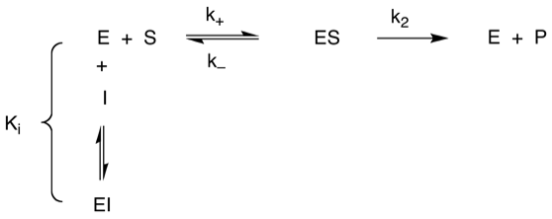

*Ki = units M or uM or nM*

*k+ units are M–1 s –1*

*k– units are s–1*

*k2 units are s–1*

7. In the paper you’ve been provided (Da Ma et al, 2012)…

7a. [4 marks] What conclusions can you draw from the NMR data in Figure 1?

Exchange is slow on NMR time scale

Host is saturated with 1 equiv. of guest (1:1 binding)

Structure of complex:

-Host protons desymmetrized by chiral guest.

-Guest proton shifts inform on structure

-Host proton shifts inform on structure

7b. [2 marks] Why are NMR titrations not used to determine binding constants in this study?

Kassoc values are too high to measure by NMR. (Kassoc values of >106 would require <1 uM concentrations).

7c. [2 mark] Why are competition UV titrations used for most guests?

Either:

* direct UV not possible because not all guests are UV absorbers. (full marks)
* Some Kassoc values (~109) are too strong to measure by UV. (part marks)

7d. [2 marks] What evidence is provided in this paper that the complexation that occurs is 1:1 stoichiometry?

NMR of host is saturated by 1 equivalent of guest. Extra guest appears as the free species, exchanging slowly, which suggests that only 1:1 binding is feasible.

UV-Vis spectra of the dye being titrated into host have an isosbestic point. Therefore, only two different species are in solution (free dye and 1:1 bound dye).