**Module on NMR of dynamic systems: practice problems**

1. The assembly of **X** and **Y** is in fast exchange. You can observe a proton on compound **X** move downfield upon addition of **Y**. Given the data below, what is the value of K11?

free = 1.3 ppm

bound = 3.3 ppm

Xt = 2 mM

Y­t = 2 mM

obs = 3.1 ppm

2. The NMR spectrum of a 1:1 host-guest complex (HG) is shown below. Signals for free and bound guest are labeled, along with their integrals.



Given the following concentrations, what is the value of K11?

Ht = 2.5 mM

Gt = 10 mM

3. The NMR in question 2 was taken at 298 K on a 600 MHz NMR spectrometer. Can you set an upper limit on the rate of exchange between free and bound guest under these conditions?

4. The analysis of higher equilibria relies on familiar tools. Consider an elongated dimeric host (below, left) that forms from two resorcinarenes “R,” and binds two deuterated benzenes “B” in *p*-xylene solution:

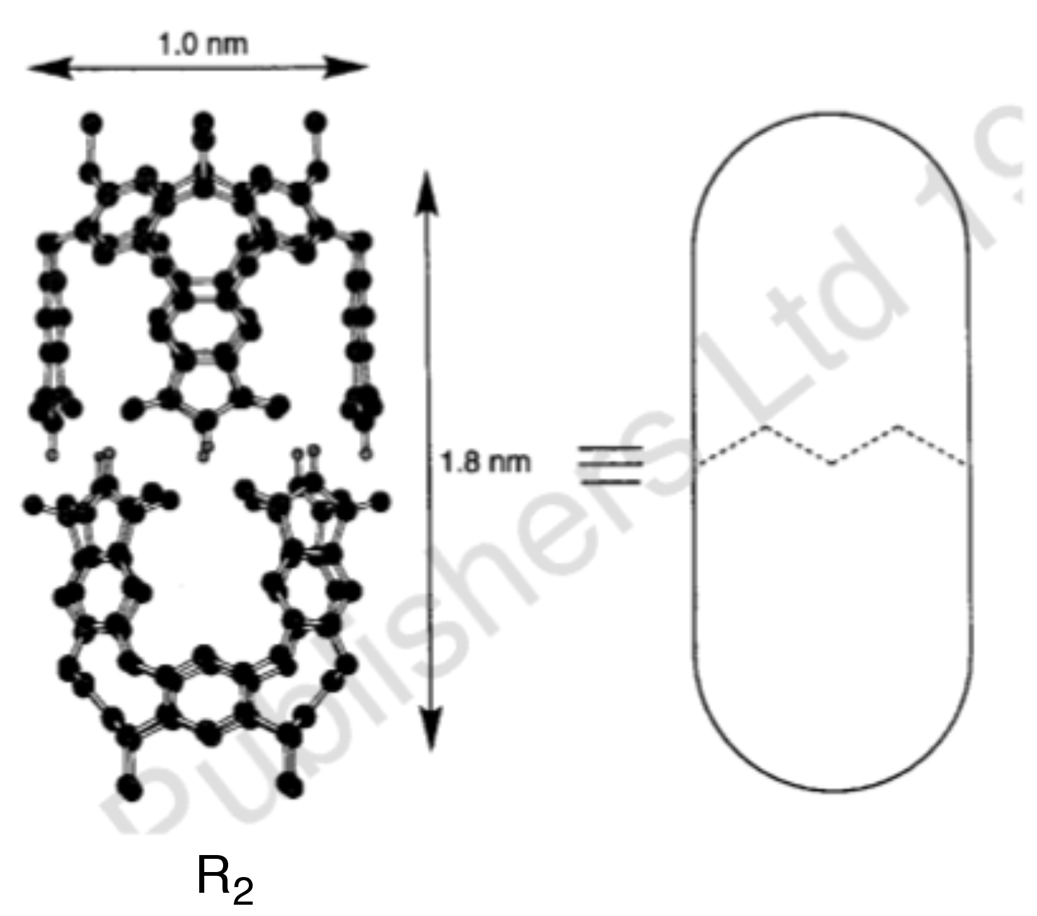

4. (continued)

a) What is the form of the equilibrium constant ?

b) Define four of the possible stepwise association constants.

c) What is the mass balance equation for the guest toluene?

d) If Rt is 50-fold higher than Bt, how does that mass balance equation change?

5. The NMR data shown below was obtained in order to analyze the 1:1 binding of Cl– to an anion receptor, whose concentration is held constant at 0.5 mM.

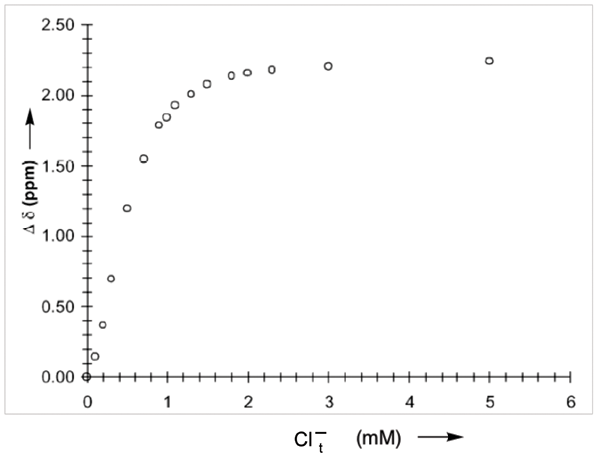

a) Describe how you would obtain a binding constant (K11) from this data *without using a non-linear curve-fitting algorithm*. Provide a detailed description that includes: the formula you would use for your analysis, what data would be plotted on each axis, the expected appearance of the resulting graph, and how you would obtain K11 from the resulting plot.

b) Choose ~6 evenly distributed data points from the curve, read their values by inspection, and plot them in their linearized forms according to your own directions. Use Excel, which makes it easy to do a linear fit by selecting the data points and then choosing the command “Add trendline…”

Solve for ∆∂max and K11. Critique your own results.

6. [4 marks] Please give acceptable units for each of the four indicated k or K values in the expression below. E = enzyme; S = substrate, P = product, I = Inhibitor.

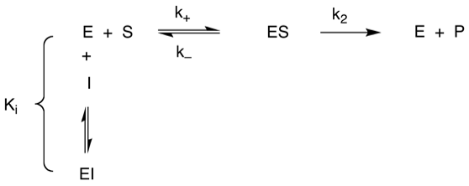

7. In the paper you’ve been provided (Da Ma et al, 2012)…

7a. [4 marks] What conclusions can you draw from the NMR data in Figure 1?

7b. [2 marks] Why are NMR titrations not used to determine binding constants in this study?

7c. [2 mark] Why are competition UV titrations used for most guests?

7d. [2 marks] What evidence is provided in this paper that the complexation that occurs is 1:1 stoichiometry?