Figure S1. Annual time series of selected zonal climate parameters extracted from NARR data provided by the NOAA/OAR/ESRL PSD, Boulder, Colorado, USA, https://www.esrl.noaa.gov/psd/. Yellow bars indicate sampling years addressed in this paper.
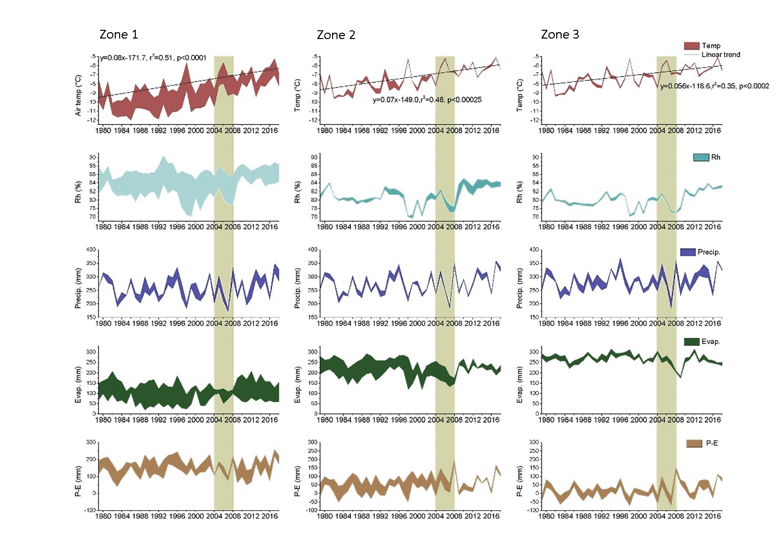

Table S1. Meteorological data for 1979–2008 (i.e., long-term mean) and the sampling period (averaged for zones) from NARR. W/D indicates wet/dry year compared with long-term mean values of precipitation. Sampling years are shaded.

Year | Temperature (°) |  |  | Relative humidity (%) |  |  | Total Precipitation (mm) |  |  | Total evaporation (mm) |  |  | Status
 | Zone 1 | Zone 2 | Zone 3 | Zone 1 | Zone 2 | Zone 3 | Zone 1 | Zone 2 | Zone 3 | Zone 1 | Zone 2 | Zone 3
1979-2018 | -8.9 | -7.4 | -7.2 | 84.3 | 81.2 | 80.2 | 268 | 274 | 287 | 104 | 209 | 267
2003 | -8.3 | -6.9 | -7.1 | 84.3 | 81.3 | 80.3 | 316 | 312 | 298 | 112 | 207 | 264 | W
2004 | -9.6 | -8.1 | -8.4 | 83.2 | 80.6 | 80.0 | 228 | 241 | 265 | 107 | 204 | 301 | D
2005 | -7.4 | -6.1 | -6.1 | 85.4 | 82.4 | 81.5 | 306 | 313 | 331 | 110 | 188 | 260 | W
2007 | -8.2 | -6.7 | -6.9 | 82.4 | 78.2 | 77.4 | 185 | 189 | 200 | 91 | 151 | 248 | D
2008 | -8.0 | -6.6 | -6.8 | 82.3 | 78.0 | 77.0 | 337 | 345 | 346 | 108 | 157 | 207 | W

Table S2. Lake and catchment summary statistics for study sites sampled during 2004 to 2008 (Kokelj et al., 2005; Houben et al., 2016).
 | La (ha) | Ca/La ratio | Z_{max} (m) | La/Z_{max}  (10³m) | Thaw slump area/lake area ratio (%) | Catchment area disturbed (%)
undisturbed lake, n=32
Median | 2.7 | 8.4 | 3.55 | 6.5 | 0 | 0
Mean | 4.8 | 8.0 | 4.3 | 18.1 | 0 | 0
SD | 6.5 | 2.8 | 2.5 | 36.1 | 0 | 0
Min | 0.5 | 2.5 | 1.5 | 0.8 | 0 | 0
Max | 32.5 | 12.9 | 10.9 | 203.1 | 0 | 0
active SRTS disturbed lake, n=13
Median | 9.2 | 4.5 | 5.2 | 14.9 | 34 | 6
Mean | 21.2 | 6.6 | 5.9 | 57.6 | 42 | 11
SD | 33.4 | 5.6 | 2.7 | 104.3 | 26 | 11
Min | 2.8 | 2.0 | 2.0 | 3.1 | 12 | 1
Max | 116.5 | 22.1 | 10.5 | 332.9 | 96 | 34
stableS RTS disturbed lake, n=16
Median | 5.4 | 3.8 | 4.8 | 13.0 | 24 | 7
Mean | 8.4 | 3.9 | 5.0 | 22.3 | 40 | 10
SD | 6.8 | 1.3 | 2.7 | 24.2 | 33 | 7
Min | 1.2 | 1.6 | 1.7 | 3.5 | 4 | 1
Max | 21.4 | 6.3 | 11.3 | 92.6 | 125 | 24
ancient SRTS disturbed lake, n=3
Median | 1.9 | 8.2 | 4.8 | 3.6 | 97 | 12
Mean | 2.4 | 8.9 | 7.6 | 3.4 | 131 | 18
SD | 1.0 | 2.5 | 4.7 | 0.5 | 70 | 13
Min | 1.4 | 6.3 | 3.9 | 2.7 | 67 | 6
Max | 3.8 | 12.2 | 14.2 | 4.0 | 229 | 37

Table S3. Pearson’s product-moment correlations between selected physical parameters for sites with SRTS. Pearson coefficient P-values <0.05 are indicated in bold.

 | Lake Area (ha) | Catchment Area (ha) | Thaw slump area (ha)
active SRTS disturbed lake, n=13
Thaw slump area (ha) | 0.93 | 0.72
% Catchment Area Disturbed | -0.24 | -0.49 | 0
Thaw Slump: Lake Area Ratio | -0.51 | -0.58 | -0.29
stable SRTS disturbed lake, n=16
Thaw slump area (ha) | 0.25 | 0.33
% Catchment Area Disturbed | -0.64 | -0.63 | 0.36
Thaw Slump: Lake Area Ratio | -0.57 | -0.46 | 0.48
ancient SRTS disturbed lake, n=3
Thaw slump area (ha) | 0.99 | 0.96
% Catchment Area Disturbed | 0.99 | 0.93 | 0.99
Thaw Slump: Lake Area Ratio | 0.99 | 0.94 | 0.99

Table S4. Sensitivity of derived isotope balance indicators to changes in input parameters (±2.5% and ±5%) using Lakes 5A (2008) and 8B (2008) as examples of high-evaporation and high-throughflow lakes, respectively. Base case represents indicator values prior to sensitivity testing.

Indicator |  |  | T |  | RH |  | δ_{A} |  | f
 | LAKE ID | Base  case | ± 2.5% | ± 5% | ± 2.5% | ± 5% | ± 2.5% | ± 5% | ± 2.5% | ± 5%
E/I | 8a | 1.2 | 1.21/1.20 | 1.21/1.20 | 1.64/0.98 | 2.87/0.84 | 1.77/0.91 | 3.31/0.74 | 1.32/1.09 | 1.44/0.99
E/I | 5b | 0.23 | 0.23/0.23 | 0.23/0.23 | 0.23/0.23 | 0.23/0.23 | 0.25/0.21 | 0.27/0.20 | 0.27/0.19 | 0.31/0.16
P/I | 8a | 1.8 | 1.80/1.79 | 1.80/1.79 | 2.45/1.46 | 4.27/1.46 | 2.63/1.36 | 4.94/1.10 | 1.97/1.63 | 2.15/1.47
P/I | 5b | 0.24 | 0.24/0.24 | 0.24/0.24 | 0.24/0.24 | 0.24/0.24 | 0.26/0.22 | 0.28/0.20 | 0.28/0.20 | 0.32/0.16
WY | 8a | -11 | 1 | 1 | 1.875 | -1.26667 | 2.285714 | 10 | 1.2 | 1.625
WY | 5b | 103 | 103/104 | 103/104 | 103/104 | 103/104 | 93/114 | 82/125 | 84/130 | 69/168
R/P | 8a | -0.04 | 1 | 1 | 2 | 3.5 | 2 | 8 | 1.25 | 1.666667
R/P | 5b | 0.36 | 0.36/0.36 | 0.36/0.36 | 0.36/0.36 | 0.36/0.36 | 0.33/0.40 | 0.29/0.44 | 0.29/0.46 | 0.24/0.59

