Presented by University of British Columbia, Simon Fraser University
and University of Victoria
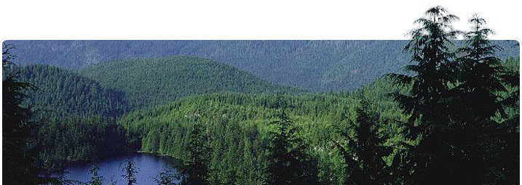

2013 LOON LAKE CELL BIOLOGY RETREAT
Friday, May 3 – Sunday, May 5

To register:
STEP 1
If you have not already completed the online registration form please do so.

THEN proceed to step 2.
STEP 2
Complete this abstract submission form with your information and include your abstract. Save the form to your desktop using your surname as part of the file name. Create an email addressed to mailto:loonlake2012@gmail.com. Attach the completed form you saved to your desktop and click send.

PERSONAL INFORMATION
Name:
Gender: | Male | Female
Email:
PI Affiliation:
Institution:
ABSTRACT INFORMATION
Title:
Authors:
Presenting Author:
Affiliation(s):
PI Email:
Abstract (250 words max.):
Type of presentation: | Poster | Oral

