Yogalicious

Observer: _______________ Participant: ____________________ 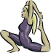 Grading Scale:
Yoga Master: Performed the cue all of the time
Yoga Instructor: Performed cue most of the time
Yoga Student: Performed cue some of the time
Yoga Mat: What cues?

Cobra Pose
Cues | Attempt #1 | Attempt #2 | Comments
1. Tops of feet on the floor

2. Breathe in as they begin
to lift the body

3. Hips and feet only thing touching the ground

Camel pose
Cues | Attempt #1 | Attempt #2 | Comments
1. Knees hip width apart and thighs perpendicular to the floor
2. Hands on the heal of the foot

3. Head looking up to the ceiling

Teacher Checklist
Rubric
1 = student showed some effort, but a lot of work is needed to meet standards
2 = student showed effort and was close to meeting minimum standards
3 = student showed effort, met standards and went beyond expectations

Student | One legged Pose  -Body control  -5 breaths  -Arms, Torso, legs parallel to floor | Sun Salutation pose  -Body control  -5 breaths  -Knee 90 degree angle  -Arms above head | Triangle Pose  -Body Control  -One hand on ankle, other extended upward  -Limbs straight | Total | Comments

Rubric
Rubric suitable to assess Personal and Social Responsibility outcomes

1  Likes to stretch | 2  Takes Yoga Class | 3  Yoga Instructor | 4  Yoga Master
-Student has a difficult time meeting criteria.  -Some effort is present, but the student must be reminded frequently to stay on task.  -Respect for peers, in groups, is sometimes present. | -Students are usually quiet while doing yoga,  -Students sometimes try every pose to their best ability,  -Students have respect for their peers  -Students sometimes demonstrate respect for peers while working in groups. | -Students are quiet while doing yoga  -Students usually try every pose to their best ability  -Students have respect for their peers  -Students usually demonstrate respect for their peers while working in groups. | -Students are always quiet while doing yoga  -Students always try every pose to their best ability  -Students have respect for their peers  -Students always demonstrate a high level of respect for their peers while working in groups.

http://www.santosha.com/asanas/trikona.html

It’s All About Me

My Score | How did I do? | Could I do more?
4  Yoga Enthusiast | - Always on time  - Tried every pose  - Came in proper attire  - Always Enthusiastic | The reason why I gave this mark:
3  Yoga’s Great | - Usually on time  - Tried most poses  - Came in proper attire  - Usually Enthusiastic | The reason why I gave this mark:
2  Starting to get it | - Attended class  - Tried most poses  - Came in proper attire most of the time  - Enthusiastic about some poses | The reason why I gave this mark:
1  Barely off the mat | - Arrived late or absent frequently  - Came in strip some of the time  - Minimal effort | The reason why I gave this mark:
Adapted from K. Brine and J. Goertzen 2005.

PLO: demonstrate a willingness to participate in a wide range of activities from all movement categories

So You Wanna Instruct Yoga?
List 4 key teaching points for the 3 following poses. (Note: Picture may only be part of the entire pose)

1. One Legged Pose:
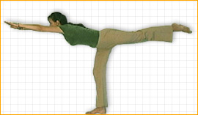

2. Salutation Pose:
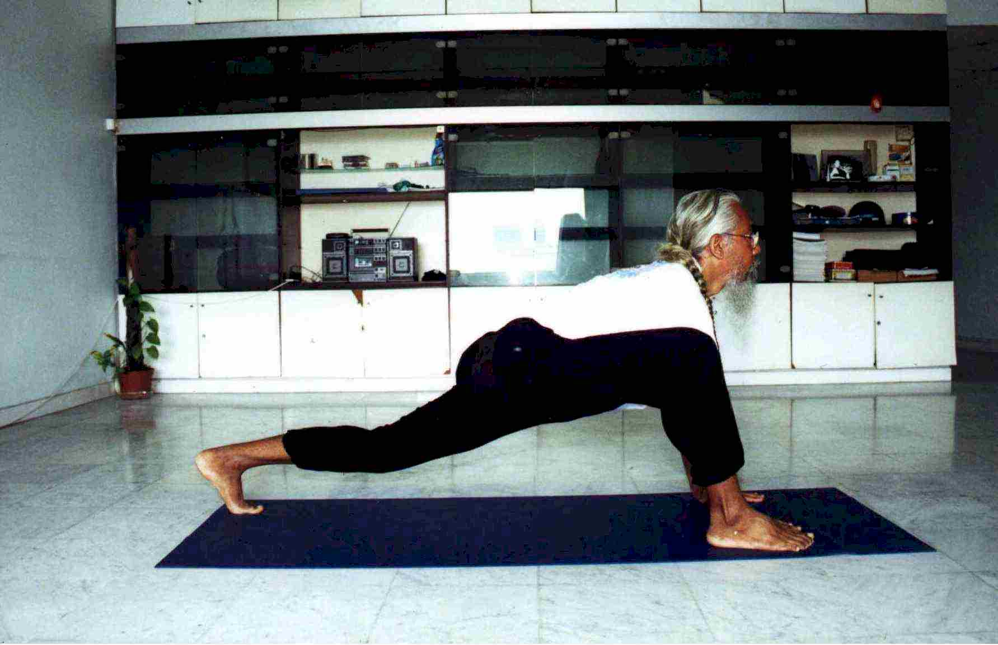

3. Triangle Pose:

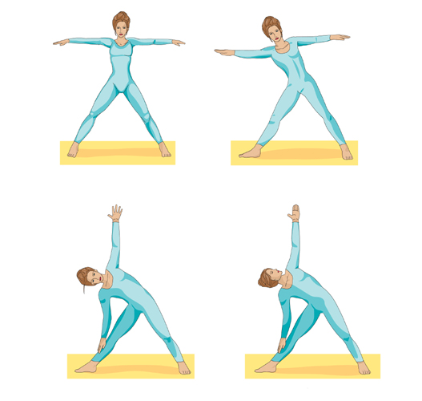

Answer Key for Becoming a Yoga instructor
(students must have 4 of the points for each pose to get full marks)
PLO: identify the knowledge, skills, and personal attributes required to qualify for specific careers related to physical activity

One legged pose:
1. Students stand with feet together and arms by sides.
2. Inhale and extend arms in front of the body, parallel with the floor
3. Bend forward at the waist and swing one leg backward (as close to parallel with the floor as possible)
4. Breath slowly through the nose, keeping arms, torso and leg parallel to the floor.
5. Hold the posture for at least 5 breaths.
6. Return slowly to standing position and repeat sequence using other leg

Salutation pose:
1. Students are on their knees with back, buttocks and thighs aligned
2. One foot is extended forward and bent at a 90 degree angle
3. Palms of the hands are placed together at the heart
4. Arms are raised straight above the head (palms still together) and head bends slowly backward looking up toward the hands
5. The back should bend slightly backwards and the back leg should be straightened (lunge position)
6. Breathing should be slow and through the nose. This posture should be held for at least 5 breaths.
7. Return slowly to standing position and repeat sequence using other leg

Triangle pose:
1. Stand with feet slightly further than shoulder width apart
2. Inhale and raise both arms out to the sides of the body (like an airplane), parallel with the floor
3. Exhale slowly, turn the torso to the left, bend at the waist and bring the right hand down to the left ankle. The left arm should be extended upward. All limbs should be straight.
4. Turn head upward to look at left arm (that is extended upward).
5. Hold this pose for 5 slow breaths.
6. Move slowly back to standing with feet slightly further than shoulder width apart. Repeat sequence turning torso to the right (and opposite arm down/up).

What do you know about Yoga???
Name: _______________ 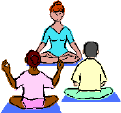 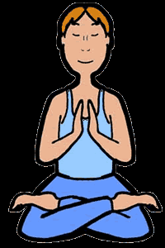

- What are the three techniques used for breathing while performing yoga poses?

__________________ , __________________ , __________________

What do these techniques do to help your body perform?

- Name 3 standing poses learned in class.

______________ , ______________ , ______________

Explain one thing that each of these poses help. (ex: Core Strength, Relaxation…)

- What are some health benefits associated with Yoga?

- Yoga focuses on the harmony between _____________ and _______________.

- Is it important to breathe slowly during yoga? If yes, why? If no, why not? (use other side of test if need be)

