Name of Activity:________________________

Tactical Problem:

Skill development:

Teaching Points  Tactic progression:  Skill progression: | Diagram  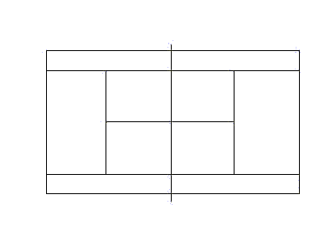
Biomechanical Reminders | Game Aim and rules.  AIM:  Rules  Extensions

