Field Hockey Lesson Plan

Lesson #: 3  Topic/Focus:  On ball skill and off ball movement  Equipment:  Cones, sticks, balls | Learning outcomes: TSWBAT…  P: ability to perform new dodging techniques  P: ability to pass to teammates and to space accurately  C: understand when to use a dodge and why  C: understand when and where to move off ball to receive a pass  A: communicate passing options and time to teammates
Movement Tasks and Management (including time) |  | Organization | Refinements/ Extension Simplifications
Introductory Activities  Flip Cone  -cones are spread out in an area approximately 15m by 15m. Half the cones are flipped up and half down  -students are split into 2 teams and the objective is to flip as many cones as you can in 1minutes  -the team with the most cones flipped in their direction wins |  | 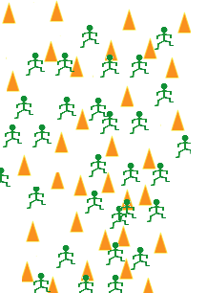 | Refinements  -remind students it is important to try to stay low when flipping the cones  -the same stance to flip the cone is used in field hockey  -try to stay low without coming up
Skills and Concept Development  Endball  Intent: score by invading opponents area to pass the ball to goal taker  -cannot move with ball and must stay in area  -if scored on defending team starts with ball; if ball goes out of play free hit on the side line for the other team  -to stop scoring ball must be intercepted  -to score pass ball to a teammate over the end line  Dodging Competition  -in partners students will run to a cone dodge a defender(cone) and pass back to partner through cones  -competition aspects includes trying to get ten dodges and passes through the cones  Types of dodges:  - pull  -curl  -pivot |  | 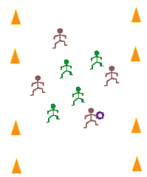  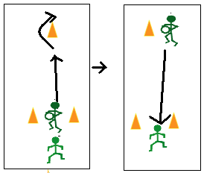 | Refinements:  -have hands apart on stick to pass ball  -get low to pass and receive  -cut into open space to receive a pass  -pass into space for teammate to run on to ball  -where do you go after you send the ball?  -where do you go when you partner receives the ball?  Extensions/Simplifications:  -add the allowing of a pull before a pass to allow for changing of angles  - simplify by having one player stay in end zone until team scores. This creates 3v3 which will create more space and time.  -increase or decrease space  Refinements:  -it is important to stay low when dribbling and dodging  -dodges take practice so start doing them slow then speed up  Extensions/Simplifications:  -increase or decrease length or width of cones  -create groups of three or four and instead of a cone defender add a person
Culminating Activity  Endball  Intent: score by invading opponents area to pass the ball to goal taker  -can move with ball but must stay in area  -if scored on defending team starts with ball; if ball goes out of play free hit on the side line for the other team  -to stop scoring ball players can tackle but must not hack or it is a free hit for the other team  -to score pass ball to a teammate over the end line |  |  | Refinements:  -important to note when to try to tackle  “When is a good time to try to tackle to steal the ball”  -the response to be found should be when the ball comes off the dribblers stick  -define hacking: not being able to hit others sticks to get ball  -important to have right hand low on stick to receive  Simplifications/Extensions:  -create a larger or smaller playing area  -add the rule that all players must touch ball consecutively before scoring
Closure  Discussion  -ask students questions about skills and concepts learned |  | 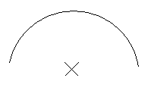 | -questions asked:  -what was hard about including dribbling in the second game of Endball?  -were the dodges learned useful?  -how were you able to get open to receive a pass  -what were difficulties found when trying to prevent scoring

