Field Hockey Lesson Plan

Lesson #: 4  Topic/Focus:  defensive positioning, offensive positioning (in relation to teammates)  Equipment:  Cones, sticks, balls,pinnies | Learning outcomes: TSWBAT…  P: ability to jockey effectively to defend opponents with the ball.  P: ability to make effective cuts to space  P:ability to make and recieve passes.  C: understand where to move in relation to teammates and opponents (offense and defense)  C: understand how to effectively defend an opponent with the ball  C: understand how to use supporting players to set up offence.  A: communicate defensive and offensive positioning to teammates.
Movement Tasks and Management (including time) |  | Organization | Refinements/ Extension Simplifications
Introductory Activities  Chinese Gates  -Intent: to get students warm through constant movement. Get students defending space and working as a team to achieve a goal.  -The attack team is trying to get their players through each stage of gates to reach the end.  - The defenders are trying to stop them by tagging attacking players in their respective zones.  - Attacking players can not be tagged within the safe zones, and offensive players can only move onto the next stage by passing through the gates. |  | 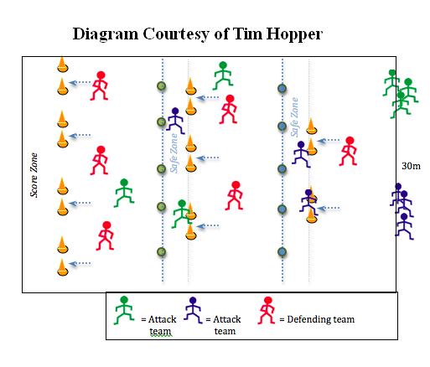 | Refinements  -Tell students to work as a team to get their teammates to the end.  -tell offenders to make crisp hard cuts.  -defenders need to be in a low athletic stance, prepared to make alot of lateral movement.  Extensions/Simplifications:  -increase or decrease size of gates  -increase or decrease the number of gates  - increase or decrease the number of defenders.
Skills and Concept Development  5 V 3 Safe Zone  -intent: to work on passing and cutting to space. As well as working on defending a goal.  -Offensive players are trying to score on the goal.  -Offensive players aren’t allowed to dribble with the ball (two touch hockey)  - Defensive players can only gain possession by intercepting a pass.  -Offensive players can only retain possession for 3 seconds.  - Defenders aren’t allowed in the safe zone.  -There must be two offensive players in the safe zone at all times. Players can rotate in and out of safe zone. Passes can be made into safe zone.  -Defenders score through intercepting a pass and making three consecutive passes to teammates. |  | 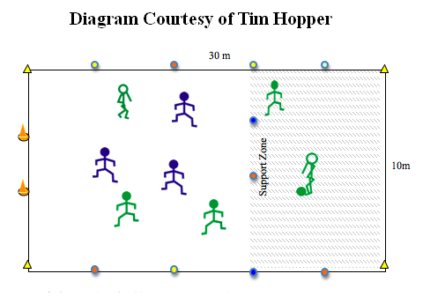 | Refinements:  -use support zone to set up your offence.  -cut into open space to receive a pass  -pass into space for teammate to recieve the ball  -defenders get into passing lanes. mark an opponent  Extensions/Simplifications:  -increase or decrease playing space, size of goal, and support zone.
Flapper Game  -intent: to work on defensive on ball positioning  -In a confined space players are trying to get past the defender without being tagged. The defender must keep their elbows to their side in order to emphasize that they need to defend with their feet rather then lunging. Drill can be done with or without field hockey sticks. progression sees, no one with sticks, to offensive player with stick and ball, to both with sticks and offender is trying to get past defender with ball.  Culminating Activity  4 v 4 with side line outlets  -intent: to play in a game like setting, with a focus on trying to pass to the side lines to spread the floor and defence.  -teams are trying to score on the respective goals. In order to score a goal they must make one pass to the side line outlet in the possession that they scored on. There must be a side line outlet at all times, and when a pass to the side line outlet is made the person who passes it in must fill their position. After a score all players must go through their goal in order to be eligible defenders. |  | 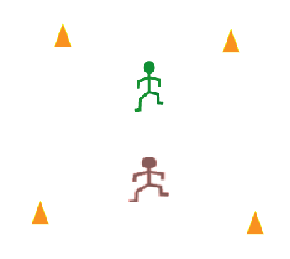  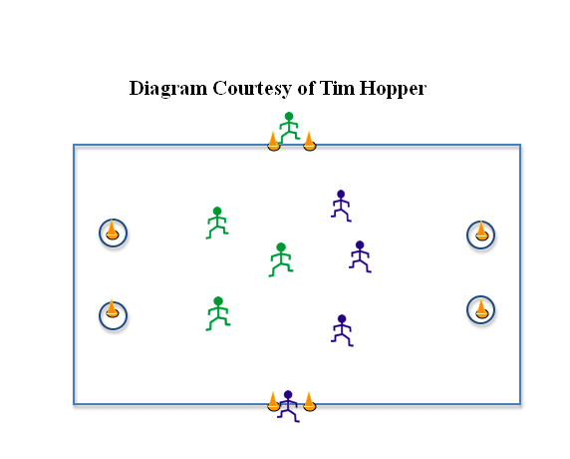 | Refinements:  -low defensive position, get to offensive player with your feet not your hands.  -defenders feet should be slightly staggerd.  -defenders elbows to ribs  Extensions/Simplifications:  -increase or decrease space  - introduce sticks and ball.  Refinements  - support your teammates.  - get in passing lanes.  - spread the floor.  -use the sideline outlet.  Extensions/Simplifications:  -increase or decrease playing space  - increase or decrease size of goal.  -take away ability to dribble.
Closure  Discussion  -ask students questions about skills and concepts learned |  | 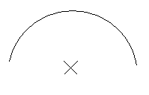 | -questions asked:  -what were the advantages of having a support zone in the 5 v 3 safe zone game?  -does passing the ball away from the goal cater to offense?  -when you were on defense during the 4 v 4 side line outlet game, what did the offense do that made it difficult for you to defend? and what did they do to made it easier?

