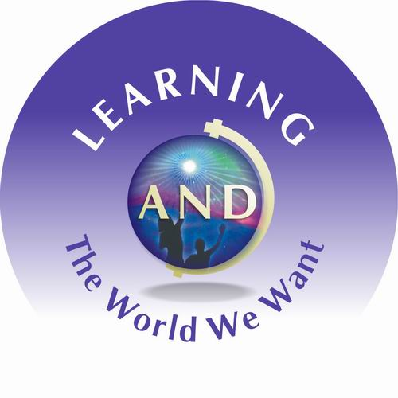

Building International Connections Through Global Arts and Child Honouring

University of Victoria Summer Institute for Educators

July 4-8(9), 2005

How do children and youth from around the globe view the world we live in?

How do we build the world we want?

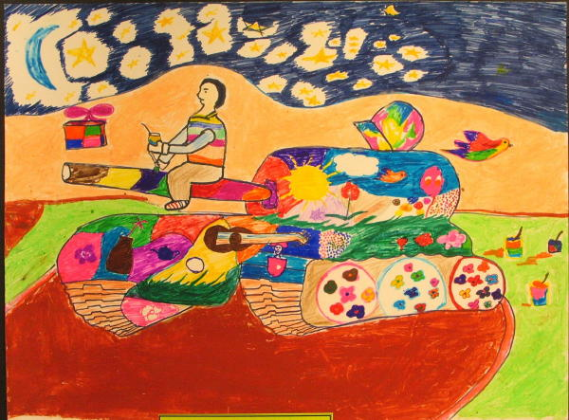
Iraqi child’s art
Canadian child’s
art
“Let peace prevail in ever country”

Spend a week with enthusiastic colleagues from around the province to:
- Engage in creative purposeful classroom projects
- Address the urgency for educators to respond to our current world
- Develop a passion for social action
- Build international connections, sustained peaceful understandings.
- Honour children rights
- Inspire democratic ideals in global learning
This Summer Institute is open to
all elementary, middle and secondary school teachers and other educators of children and youth who are committed to building “the world we want” through global arts and the honouring of children.

The Concepts
Global Arts represents the use of creative and cultural forms of artistic expression to impart images and impressions of the world we live in and a vision for the world we want. Through multiple modes of expression, we can create images of our world to elicit global kinship and social responsibility.
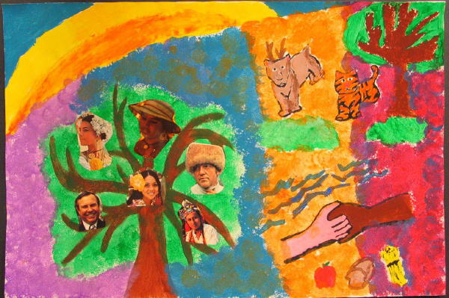
Global Arts Institute
Child Honouring recognizes children as significant participating members of our communities, endowed with innate and intuitive intelligence. The principles of Child Honouring, a philosophy articulated by Raffi, the Troubadour Foundation and many partners, call for a global commitment to all children, that they be kept from harm and neglect, and that they will inherit a world that is sustainable and free of environmental devastation. For more on Child Honouring, please go to http://www.troubadourfoundation.org/
Co-operation: Different cultures need to cooperate in areas like eliminating war or racism

The Summer Global Arts’ Institute will provide you with an array of practical and community-based activities that highlight the visions and possibilities for Global Arts and Child Honouring. For the week of July 4-8, 2005 the following experiential opportunities will be offered:

- Proposed opening dance, song, & storytelling performance put on by Astrid Sherman’s Pro-Arte dancers
- Hands-on workshops and direct experiences (engagement with performing, visual, & physical arts; the rights of the child, and Raffi’s covenant for child honouring)
- Exposure to global arts & child honouring curriculum
- Involvement and collaboration with children and youth
- Engagement with an international children’s art exhibition
- Opportunities to counter the commercialization of children and take action on issues of injustice and democratic ideals (awareness of media literacy, propaganda, child marketing)
- Opportunities for creative self expression
- Support & studio time for developing related ideas and initiatives using multi-media
- Participation in a range of graduate class experiences
- The opportunity for international networking and partnership development with community members, organizations, & agencies
- A village festival to celebrate community and the many wondrous global arts and child honouring initiatives

Background

This professional development institute builds on “The World We Want” project and Conference that attracted children’s artwork from Canada, Afghanistan and Iraq.
The resulting display has raised global awareness regarding the rights of children, the importance of listening and responding to children’s voices, and the value of building international relations in a shared quest for world peace, justice, and environmental sustainability.

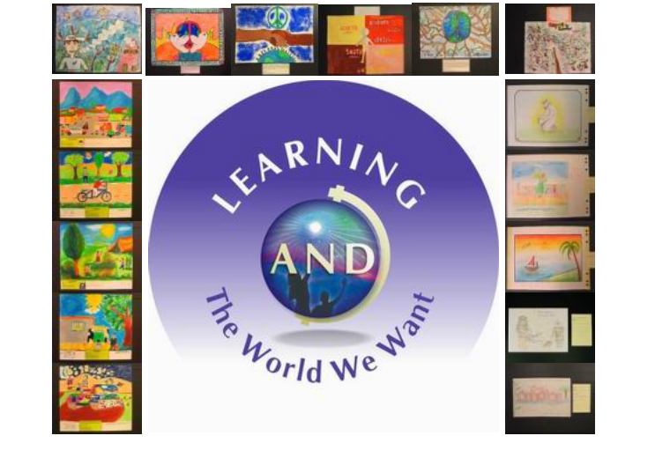

See art catalogue and story of how the Iraq and Afghan artwork came to Canada at

http://www.educ.uvic.ca/site/Lawwwart/lawwwart.htm

A Community-based Adventure on Salt Spring Island

For those who would like to enrich their understandings of Global Arts and Child Honouring, an “Earth Arts” day trip to Fulford Elementary School on Salt Spring Island (working with Raffi’s Troubadour Foundation and Gulf Islands Center for Ecological Learning-GICEL) will be offered for Saturday July 9. For more on GICEL, please go to http://www.sd64.bc.ca/~gicel/

A Lasting Venture:

This Summer Institute will also provide support and opportunities to sustain ideas and partnerships, and to present ongoing projects and initiatives at Vancouver’s World Peace Forum, June 2006.
Participants will receive a Certificate of participation and global arts resource DVD upon completing the Institute.
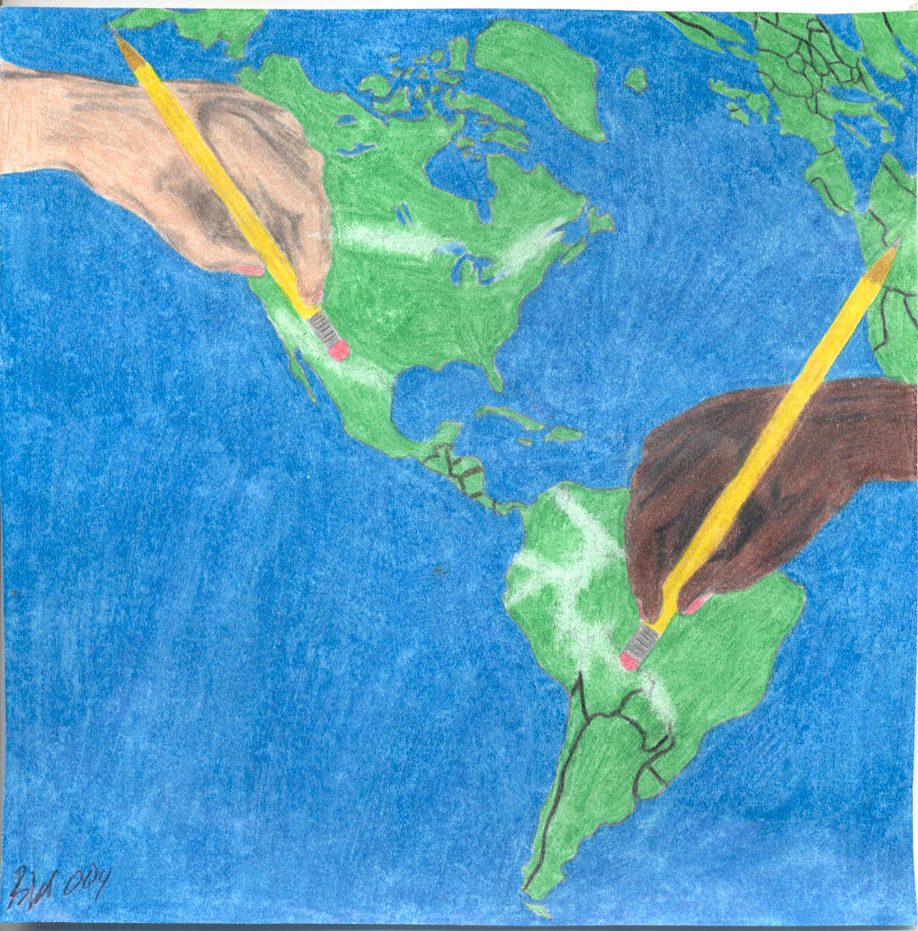
Registration

Date: July 4-8, 2005

Cost: $100 (plus GST)

Location: University of Victoria

Time: 9:00 – 11:30 and 1:00 – 2:30 M-F

Deadline: May 15th

Register on-line at

https://www.uvcs.uvic.ca/forms/confreg/lwww/

OR

Contact conference registration office at
250 472-4747 for telephone registration. Prepare with name, organization, address, e-mail and payment details.

For inquires regarding institute and alternative registration method (cash or cheque) contact Nadine Cruickshanks at

250 721 7806 or e-mail nadineho@uvic.ca.

In addition, institute attendees have first option on the July 9 Salt Spring Island day-long GICEL workshop.
Cost: $50 Cdn plus tax.
Contact Nadine Cruickshanks to confirm a place.
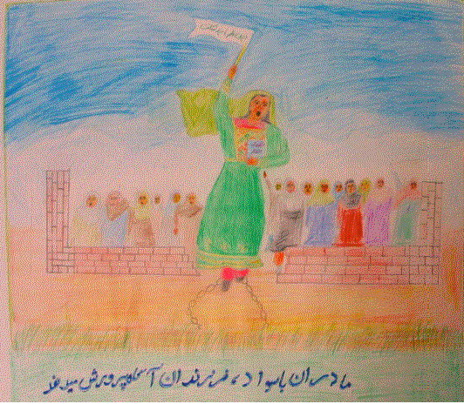
Mothers that are educated can teach their children well

Afghan child’s art

