Wolff-Michael Roth
Talking Careers, Career Talk
Conversations, such as those that make interviews, generally are analyzed in terms of the content of the talk. This talk tends to be attributed turn by turn to individual speakers, as if what one person said was independent from what another person said, somehow a reflection of what is in the mind of a person. Such an approach, however, does not allow us to understand how a conversation unfolds; it does not allow us to understand the conversation as a dynamic event in and off itself.
Classical perspectives on language assume that to engage in conversations means for individuals to produce utterances that are instantiations of the grammar that the speaker has learned before. The grammar provides patterns – subject (noun), predicate (verb), object (noun), and so on – and slots into which appropriate words are plugged.
there is no such thing as a language, not if a language is anything like what many philosophers and linguists have supposed. There is therefore no such thing to be learned, mastered, or born with. We must give up the idea of a clearly defined shared structure which language-users acquire and then apply to cases. . . . we should give up the attempt to illuminate how we communicate by appeal to conventions. (Davidson, 1986, p. 446)
The traditional approach does not explain how two individuals interact, especially if at least one of them has never talked about a particular topic. Even more interestingly, people not only make conversations in talking, they also make the kind of situation they find themselves in even if they have never been part of such a situation before. For example, only occasionally do students participate in interviews generally, and even more rare are iterations of particular types of interviews about specific topics. What they are to do is itself emergent from the situation to which they contribute to bring it about. The ultimate question, therefore, will be to understand how two individuals pull off an interview given that they have not had done this together before.
The position we take in this chapter is that interaction participants do not find themselves in an interview as if it were a box, with a precise scenario for what to do and say that they implement in a mechanical way. Especially because neither participant can know beforehand what the other will say, the interview as process (event) and the interview content emerges from the interaction. Therefore, neither process nor content can be predicted on the basis of what we might think to know about the individual participants before their actual meeting. In fact, if we could predict what will happen and what they will say, they would not have to convene, but we could somehow compute the content.
At the same time, the two will not produce just any kind of situation. What they do is recognizable as an interview, even though the specifics cannot be predicted. Moreover, what they say in terms of content is recognizable as contribution to an interview about possible futures and careers. There is therefore a dialectic at work between the cultural possibilities (including language) available and the way in which specific possibilities are concretized. A lot of the interaction therefore requires coordination work, and participants make this coordination work itself available to one another.
Participating in an interview, therefore, means participating in a creative endeavor. One part of the outcome is the interview context itself; another part is the text realized, which comes to be transcribed and used as data source. The outcomes are not willy-nilly, because, as is the case for artists in other domains, there is not unlimited freedom of expression if the artist is producing for another, who is to understand and appreciate. The participants in an interview about possible future selves and future careers are oriented toward the intelligibility of what they say, both with respect to one another as to the intelligibility of the ultimate text that emerges, which, in the present case, would be an account of the possible future selves and future careers that high school biology students envision.
One way of understanding language and life is to think of language as a game in the way Ludwig Wittgenstein has done, which comes with a sense that players develop for the different kinds of moves that it allows, much in the way as described by Pierre Bourdieu. But just as in any game, what actually happens on the field cannot be predicted, though any situation can be assessed after the fact in terms of this or that explicit rule. Knowing the rules, however, does not mean the same as being a good player. Many a sports journalist has never reached any proficiency in the games that the comment. What is required on the field is a sense of the game, a sense of what to do next. Playing hockey, soccer, tennis, or football means dealing with the unpredictable, making the best plays in the situation at hand, which itself cannot be predicted. Much like a jazz improvisation or a jam session, knowing how to play and participate goes far beyond knowing any rule, and, in fact, it does not take knowing rules to be good at a game. We know this to be, because children and many adults are highly proficient speakers even when they know no formal grammatical rules at all.
Making the Interview
The purpose of this chapter is to show that interviews are not means to make content flow from the mind of the interviewee, as if there were to be prefigured content that the interviewer helps to be express like pushing the sides of a toothpaste tube to make the contents ooze out. Interviewer and interviewee not only collude to produce the interview text, part of which subsequently tends to be ascribed to the interviewee as an individual characteristic, but also work together to produce the interview as context. That is, both (interview) text and context are produced together and even require the collaboration to produce anything recognizable as, here, an interview concerning career, possible selves, identity, or ability in science.
In this episode, we join Pei-Ling and Jennifer about 28 minutes into the interview (Figure 2.1). They already have gone through the process of getting started, explaining the purpose of this session, and produced the map by fixing the Post-It notes. The entire episode is actually framed as such by the interviewer, who introduces a topic (turn 01) and, in following up with another topic (turn 28), concludes the topic. In fact, it is not just Pei-Ling the interviewer who begins, but the beginning and ending of the episode are achieved together. In the turns from 01 to 05, the two interaction participants achieve an offer/acceptance pair, with some conversational repair concerning the word “experience.” In the interaction, each produces not only content, which researchers often attribute to the inside, the subjectivity of the person producing the locution, but they also produce the context. The interviewer (Pei-Ling) not only asks the interviewee (Jennifer) to reveal certain contents of her thinking, but also she asks a question, or rather, she offers the first part of a question–response pair. In asking a question, the interviewer produces context, because she could have done something else, in which case we might have recognized the event as belonging to some other category, for example, a tutoring session. In one of our research projects, this is precisely what happened when interviewees, asked to provide their expertise advice concerning graphs began to ask the interviewer whether they were right. As a result, and again as a collaborative achievement, the interview turned into a tutoring session, where an undergraduate physics and anthropology major tutored one of his physics professors on how to read graphs, including in the field of physics.
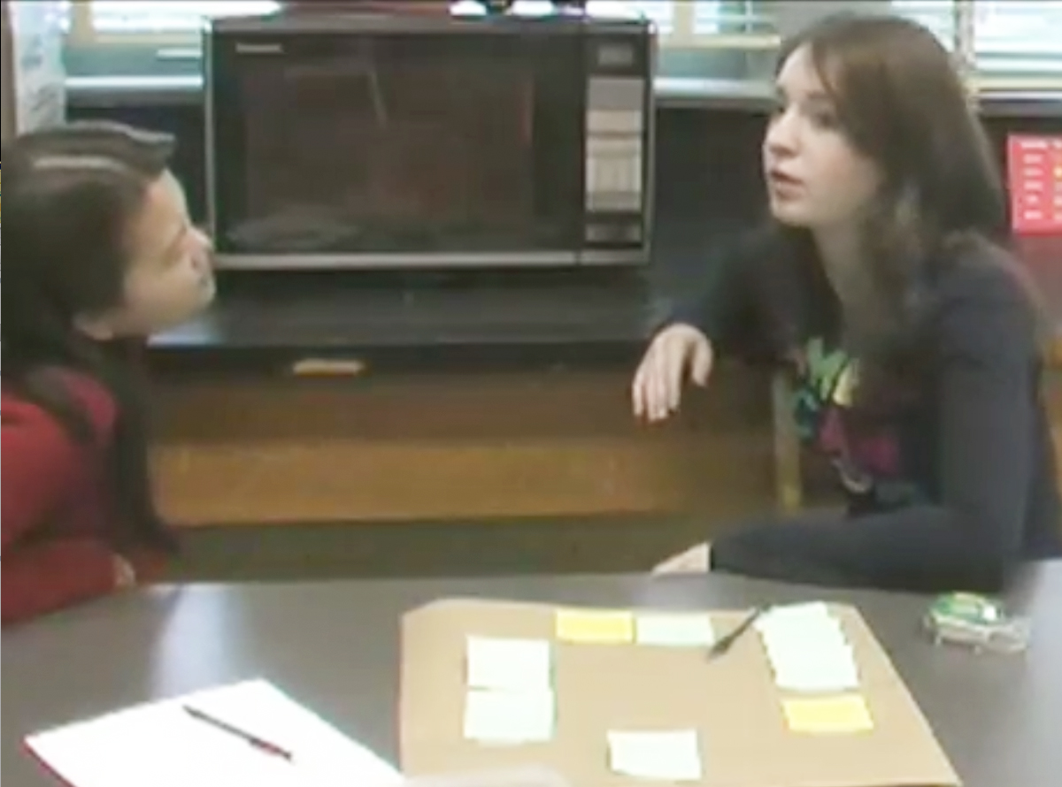
Figure 2.1. In the interview setting, the interviewer (left) and interviewee sit in plain view of each other.
The Interactional Work of Producing a Question
Interviews are often thought in terms of the information processing metaphor. The interviewer asks a question, which solicits recall on the part of the interviewee, who, after finding the appropriate information for the response somewhere in long-term memory, produces it in short-term memory and then spills it out by means of language. Close analyses of videotapes and audiotapes of face-to-face or telephone interviews shows that answers are coproduced so that what is being said in response to a question cannot be ascribed to the interviewee alone. In the present context, we actually have evidence that the same is the case for the interview question. The interviewee “helps” to get the appropriate words that complete the question in a proper way and thereby makes the latter part of the record.

Fragment 1a
01 P: so before the bamfield experi (0.25) ment you (0.39) <<grimaces>no> [experience]
02 J: <<smiling>[experience]> [heha
[((P smiles))
03 (0.24)
04 P: [ya] (0.15) ye (0.13) you di=nt want to be] a::=
[((J continues to smile)) ]
]
05 J: =i kind of did like i that was jst like (0.40) i thought it=d be really cool (0.22) ((J looks at P, P nods, who continues for a while but stops as J has gaze directed into the room)) a::nd i=d been thinking about it and i was like ↑wELl maybe it will work; maybe it wo:nt, ye know;
06 [(0.34) ]
[((J’s hands wave back and forth))]
07 P: uh [um]
[((nods)) ]
08 J: [st] kinda see where] it [goes
[ ((P nods)) ]
<<p>and then I went to my parents and i was just like>] i ↑wanna be a marine biolo[gist]
09 P: [u::m]
10 (0.80)
11 J: that was so cool
12 (0.22)

The opening shows how the two are aligned. At the end of the sounding out of “experiment,” the interviewer is position as in Figure 2.2a. The video offprint shows how the interviewee squarely gazes at her. What we can hear as the difficult production of the word experiment, including the pause in the middle of the word, occurs in plain sight of the intended recipient. There is then a marker of something gone wrong, “no” (turn 01), followed by another word beginning with the syllables, “experi” but completely differently, “ence.” . . . Pei-Ling utters “ya” (turn 04), which can be heard as completing an offer (the word “experience”)–acceptance (“ya”) pair.
At the same time, we see the interviewer bring up her hand and produce the shape of a hand attempting to grasp something (Figure 2.2b); the arm is slightly lowered forward together with the upper body and head, as if there were some problem in bringing forth what is to be articulated (Figure 2.2c). Jennifer breaks a smile and continues doing so while the interviewer, too, breaks out into a smile (Figure 2.2d). There is a brief pause (turn 03), and Pei-Ling then utters an elaboration, “ya, ye, you didn’t want to be a . . .” The utterance remains grammatically incomplete, as, following the drawn out sound of an “a” Jennifer already begins what we can recognize as the second part of a question–response pair.
In fact, we may gloss what we see here as an event in which the interviewee assists in the production of the appropriate question, as she produces the correct term to be used simultaneously with the interviewer, who, in uttering, has produced a self-correction. First, in producing the same word as Pei-Ling, Jennifer exhibits something that we have come to know as participative thinking: Without being aligned with her interlocutor, Jennifer could not have produced the appropriate word, here acknowledged by Pei-Ling as the right one (“ya”). In fact, participative thinking allows anticipation so that two speakers may articulate the “same” issues even using the same words, such as when Jennifer and Pei-Ling utter the sound-word as part of a repair of what the latter had previously said.
We can see what happened as an offer–acceptance pair. The interviewee offers the word that better and more correctly fits a question in the present content. The interviewer accepts the offer (“ya, ye” [turn 04]) and uses the corrected situation as the background for completing the question, which they realize to have been about becoming a marine biologist. That is, as the events unfold, the two achieve the question to have been about whether Jennifer (interviewee) had or had not the desire to be a marine biologist prior to the Bamfield experience: In turn 08, Jennifer articulates that it was after this experience that she had gone to her parents to tell them that she wanted to become a marine biologist. (On how they arrive at this answer, see next section.) That is, we can see Jennifer as assisting the interviewer to get her question; and it turns out here that the interviewer produces the correct word to complete the question at the same time as the offer coming from the interviewee.
We can see the turns of grinning and laughing as signs that each has recognized the situation for what it is: The interviewer has had some difficulties producing the question. Pei-Ling expresses this difficulty in the body movement associated with the verbal problem, she self-corrects/receives an offer for correction, and accepts the correction. Both mark this interaction sequence by grinning and laughing, each having available the preceding expression, so that the changes therein can be seen with respect to what has happened at the instant.
In a way, the situation might be glossed as an embarrassing one, where an interviewer has difficulties doing what she is supposed to do. But the mutual grins and smiles allow a situational understanding of benevolence, on the part of the participant, and an institutional order in which the researcher is not – as often portrayed in the literature on qualitative methods – in a power over situation. In this situation, it is not the interviewer with an upper hand over the interviewee. If anything at all, it is the interviewee with the upper hand, she provides the correction, and she provides an accepting facial expression – as if not getting the right word out is something that may happen to any one.
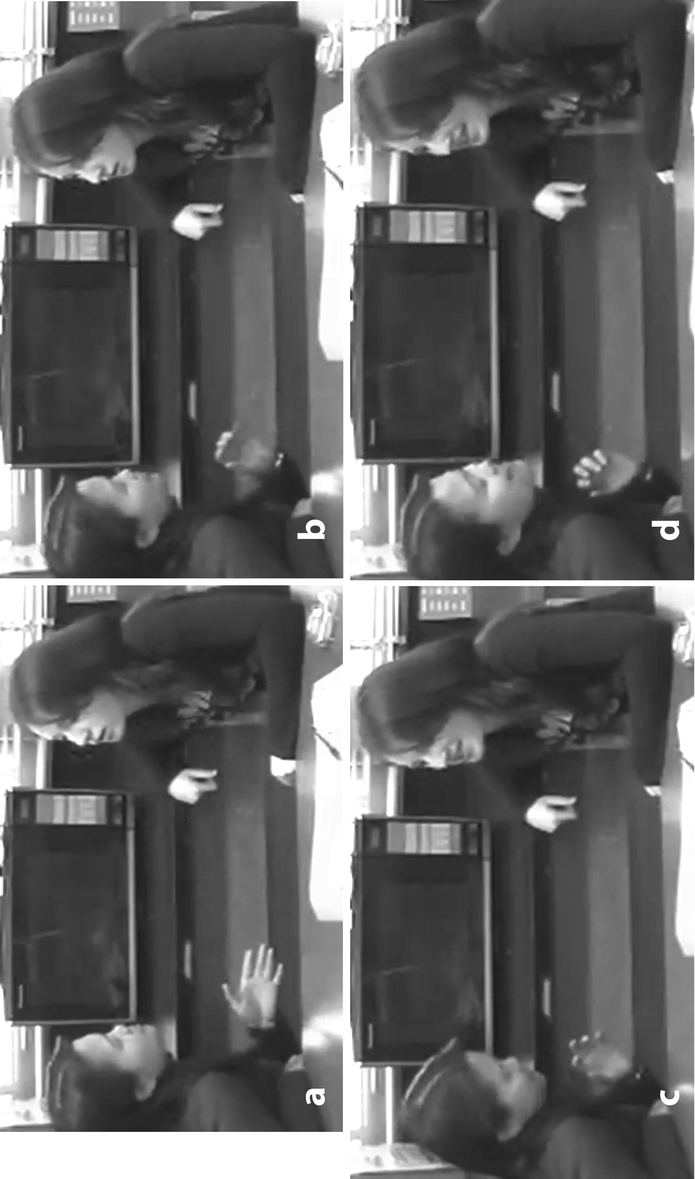 | Figure 2.2. The interviewer and interviewee use orientation, body movements, and prosody as resources for producing the context in talking (texting) so that the difference between text and context becomes undecidable.

The Interactional Work of Producing an Answer

The Interactional Work of Producing a Topic
((Bamfield, parents, marine biologist, -- Vancouver, aquarium

Fragment 1b
13 P: s:O: you think [itsa] good care[er fer ] [you]?
[((points toward map))
14 J: [((nods))]<<f>[yea]> ((looks at the map)) i think itll work out actually. (0.25) i=m really excited to see if it comes through ((nods))
15 P: <<nodding>you think itsa good career [for you]>
16 J: <<f, nodding>[yea: i ]>i think
17 (0.18)
18 P: uh um
19 J: =i mean (.) there arent, (0.27) thAT many (.) <<p>jobs
available but i mean> (0.26) i could always move over to vancouver; ((looks at map)) <<dim>a::n:d (.) work the aquarium there; or in> (.) it gives me a lot of travelling options which i=m really excited about,
20 (0.28)
21 P: uh [um:: ] ((nods, J’s gaze toward map))
22 J: [becau]se (0.20) i really like (.) t travel
23 (0.20)
24 P: uh u[m] ((nods, J’s gaze toward map))
25 J: [a]::nd; so::; (0.43) <<dim>i think that would de:>; (0.48) it it really incorporates a lot of my interESts ((looks at P))
26 P: ((nods)) uh hm
27 J: ((looks back at map, P keeps on nodding, till J looks back at her)) a:nd i love being in the lab; and i love analyzing things; and dissecting an (0.43) ah look into a
microscope <<p>and stuff like that> ((looks at P))
28 P: ((nods)) and whats your meaning of tRAvel;

The Interactional Achievement of Narrative Coherence
(genres as resources and outcomes, recognizability, not only between them, but the generalized other as well)
speaking for the other, using the language of the other, to whom the language thereby returns
Irreducibility of Interviews
In this chapter, I provide examples of the evidence that can be mobilized to show that interviews are the result of interactional work. Here, interviews are considered both as context and as text that the interlocutors produce. The participants make available all the resources that they mutually need to make the situation recognizably an interview, and the text, therefore, the result of an interview. Throughout this chapter I show how interviewer and interviewee collude to produce both context (the interview) and text (the transcript of the conversation). But they produce text and context simultaneously, with the same forms of conversational actions, so that the difference between producing text and producing context becomes undecidable. Conversational figure, what they are talking about, and conversational ground, cannot be distinguished, the presuppose each other, even though social science research often focuses on the text alone.
Throughout the chapter we see the intense cooperation to produce not only the context (the interview as event) but also the content (the interview as information captured in the text). What the precise question the interviewer asks is the result of their cooperation that brings forth the precise nature of the question and the precise words being used. What the precise response comes out to be also is a result of an interactional process that includes, at the end, markers of the adequacy of the response achieved. Thus, as soon as the interviewer moves on to another item, she also marks that whatever has been talked about before is being closed. This closure may have different reasons, which even the interviewer may articulate differently from an a posteriori position. But as an interactional moment, moving on signals that there is nothing that further talk can add, at least at this very instant, to what has been said.
Fundamentally, therefore, we can consider it to be illegitimate to reduce parts of the text and attribute it to the individual speaker. Doing so is like asking which hand is responsible for the clapping sound; or, conversely, asking what is really in the interviews mind is like asking for the sound of one hand clapping. We can also consider the issue under a different light, from a collective perspective, and say that the features we can identify in an interview situation are characteristic of the collective rather than of the individual.
References
Davidson, D. (1986). A nice derangement of epitaphs. In E. Lepore (Ed.), Truth and interpretation (pp. 433–446). Oxford: Blackwell.

Appendix
The following transcription conventions are used in this chapter:
tRAvel | Capitalization indicates emphasis;
(0.25) | Pause in one hundredth of seconds;
(.) | Pause of less than one tenth of a second;
biolo[gist]  [u:m ] | Brackets indicate degree of overlap of two speakers;
di=nt | Equal sign indicates latching (no pause) between speakers or in sound production of the same speaker;
.;,? | Punctuation transcribes the pitch movement toward the end of the utterance strongly down, slightly down, slightly up, and strongly up, respectively;
<<p>jobs> | P stands for piano, lower than normal speech volume for the bracketed word, here “jobs”;
<<f>yea> | Forte, louder than normal speech;
<<dim>and > | Diminuendo, lessening speech volume;
a::n:d | Each colon indicates lengthening of sound by about one tenth of a second;
↑wELl | Arrow indicates upward jump of pitch;
hh | Release of air, hearable out breathing.

