

Preservice teachers will often initially teach the way they were taught (Britzman, 1991; Lortie,1975). Despite the influence of teacher education programs, many beginning teachers maintain traditional, custodial practices in schools. It can be argued that schools socialize preservice teachers into traditional, outdated pedagogy and that teacher preparation programs do not ad- equately equip preservice teachers to handle the demands of teaching (Tabachnick & Zeichner, 1984). How- ever, as Siedentop and Locke (1997, p. 32) have argued, the profession has not addressed either of these issues. These authors recommend "systemic change requir[ing] institutional arrangements" and social cohesion on a common philosophy for physical education. But how do individuals work together to change the system that perpetuates traditional practices? How do individual teachers gain insights on each others' beliefs about teaching physical education? How do individuals construct their understandings of effective teaching? These questions cannot be answered simply, but the answers must be sought. An important first step is for a teacher to gain a clear understanding of what he or she be- lieves is important in effective teaching.
The foundation of one's sense of effective teaching rests on the experi- ence of being taught. This experience may either screen out much of what is taught in teacher preparation or create the framework for personalizing professional knowledge into practice. As the reflective-practitioner move-
SeptemDer l!l!l!l. JUPtNU. VOl. IU No.7
TIM HOPPER
ment in teacher education advocates, we need strategies that enable preservice teachers to frame and reframe their sense of effective teaching (Schon, 1983, 1987). Such are framing moves preservice teachers from their experience of being taught to their experience of learning to teach.
This paper will: (1) outline how to use a psychoanalysis tool, known as a repertory grid, as a reframing strategy in a teacher preparation course, and (2) show how the repertory grid enables preservice teachers to articulate their personal beliefs about teaching.
Psychologist George Kelly (1955) developed the grid based on his per- sonality theory of personal construct psychology (PCP). The theory is cen- tered on the notion that we construct what we experience based on our previous experiences. Kelly worked in an age that hoped to use rationalism and scientific methodology to understand and predict human behavior. How- ever, Kelly grew skeptical of such hopes and goals; he came to believe that individuals have the same capabilities as scientists to observe, analyze, and predict their own behavior as they construct the reality before them. In Kelly's words, "One does not learn certain things merely from the nature of the stimuli which play upon one," rather a person "learns only what his framework is designed to permit him
to see in the stimuli" (Kelly, 1955, p. I 79). So, how do teachers construct I
the reality before them? What do preservice teachers use from their pre- vious experiences to make sense of what they see and interpret in their
own actions as beginning teachers?
Kelly's repertory grid allows pres- ervice teachers to create a grid matrix comparing a list of teachers they have experienced to their own list of bipolar constructs (more about this later). This grid enables them to compare a wide array of teachers from their past. By comparing the characteristics of different teachers, preservice teachers gain insights into how they construct their implicit beliefs about teaching. Teacher educators such as Diamond (1991), Hunt (1987), and Pope and Keen (1981) have high- lighted how to use the grid and other techniques from PCP.
I How the Grid Works
In creating the repertory grid, preservice teachers are asked to select effective and ineffective teachers from their pool of past teachers. By classify- ing teachers they have experienced as effective and ineffective, participants are defining the characteristics that, in their experience, imply effective- ness in teaching. For example, 11 specific teacher roles appear in the tem- plate shown in figure 1. These teacher roles represent the types of teachers most physical education teacher education (PETE) students would have experienced. This list of teacher roles could be tailored according to the participants' experiences and interest. For example, teacher role titles such as "university lecturer" or "elementary teacher" could be used. Using the list of teacher roles, the participant assigns eight or nine memorable teachers to the appropriate role titles. A
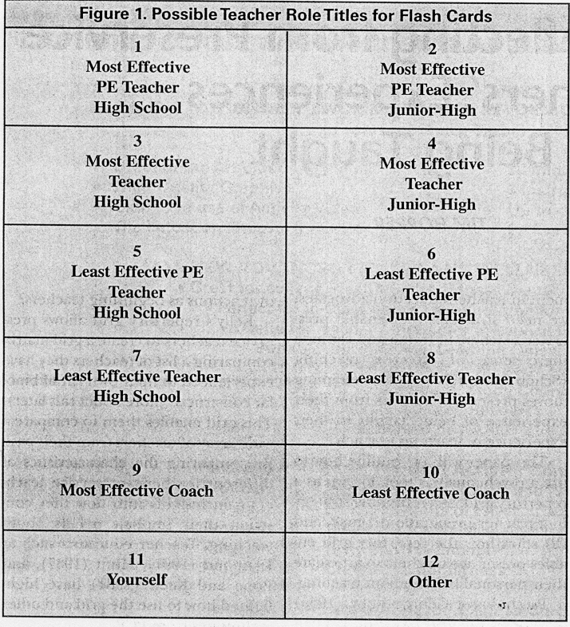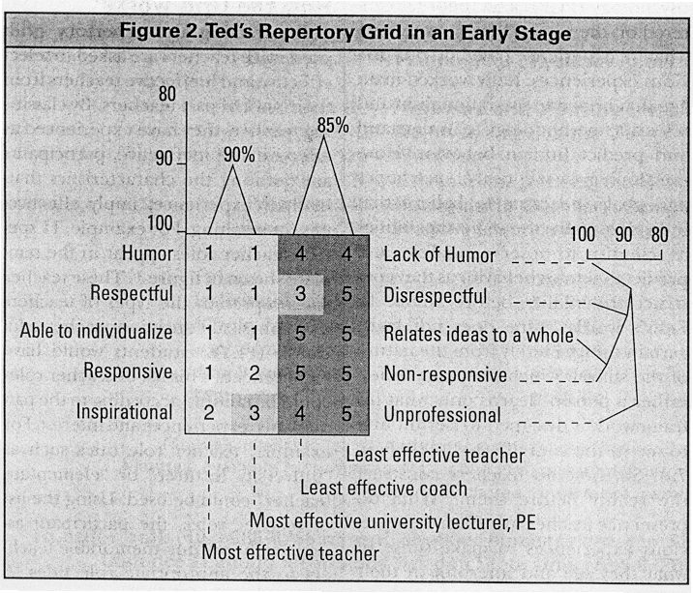

~4
teacher role title "yourself' is also included to allow participants to com- pare themselves to their past teachers.
In asking the participant to select from a pool of teachers from different times and contexts, the repertory grid creates a process where the student teacher is comparing, contrasting, and synthesizing the similarities and differences between teachers. Normally, this process would be too complex to consider with any more than a few teachers. However, the repertory grid allows the student teacher to consider eight, ten, or twelve teach- ers at one time.
A simple method for creating a grid is to write the teacher roles, along with the names of the assigned teach- ers, onto flash cards. The participant is randomly dealt three flash cards and then is asked to arrange them to indicate two teachers who are in some way similar to each other, but different from the third teacher in terms of effective teaching. The par- ticipant can change any of the flash cards for another if he or she struggles to find any contrast between the teachers on the cards. From the comparison of the teachers, a participant constructs a descriptor for the two similar teachers compared to the third teacher. For example, two teachers could be "responsive" compared to ariother teacher who was "non-responsive." When connected, these two descriptors are known as a bipolar construct. This process of creating bipolar constructs is repeated until the participant feels that a reasonable stock of them (usually about eight) exists.
Using -.t1-t()-5 rating scale, the par- ticipant then rates his or her selected teachers based on the list of bipolar constructs. For example, with the bi- polar construct "responsive/non-re- sponsive" 1 represents "very respon- sive," 2 represents "somewhat respon- sive," 3 represents "neutral," 4 repre- sents "somewhat non-responsive" and 5 represents "very non-responsive." This rating process produces a repertory grid where each teacher has a number pattern of ratings related to the bipolar constructs.
Vol. 70 No.7' JOPERD. September 1999
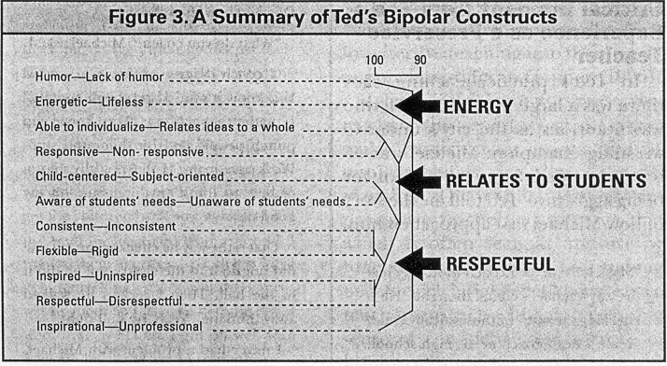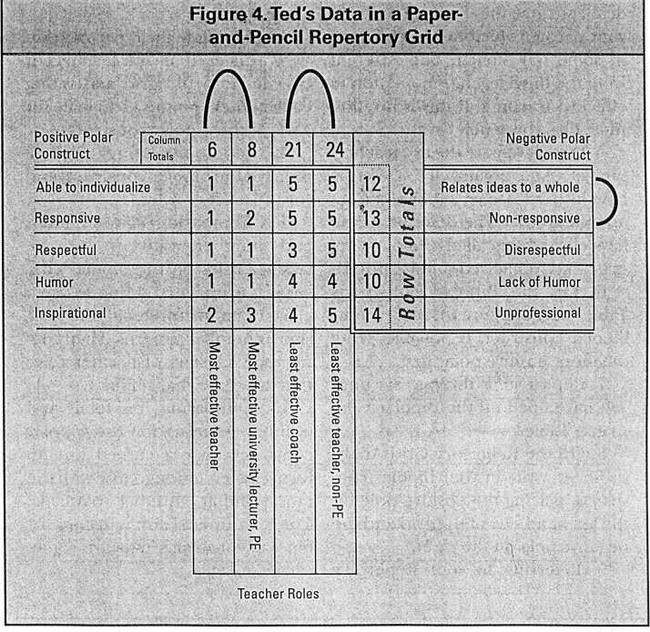

The most effective way to create a repertory grid is to use a computer software package. Figure 2 uses the computer program RepGrid 2 (Shaw, 1991) to create a repertory grid. The example in figure 2 is taken from the early stages of a larger grid that a preservice teacher, Ted, produced.
As shown in figure 2, the computer software for the repertory grid allows the number patterns for each teacher role title to be correlated with other teacher role titles with similar number patterns. This correlation creates a clustering analysis shown by a tree diagram. This clustering process highlights the commonalties between teachers identified as effective and ineffective by the participant. Often these commonalties can be specifically explained through the participants' stories about the teachers. For example, Ted felt that the two effective teachers he identified related well to all students. On the otherhand, the two ineffective teachers focused on the elite athletes. For example, the "least effective coach" and the "least effective teacher, non-PE" both focused on the best players or the best academic students. Ted supported such insights with specific examples that offered a frame of reference for his experiences of effective or ineffective teaching. As Ted said, "The least effective coach tended to bench players she saw as less able and to over-play his favorite players."
The bipolar constructs are produced from the comparison between
sociation of these two bipolar con- structs with a tree diagram showing a 95 percent similarity between number patterns. As more teacher roles are added to the grid, this association between the two bipolar constructs could change or be maintained. As more bipolar constructs are added, they may also associate to these two bipolar constructs or to other bipolar constructs to form different clusters of bipolar constructs.
the teachers selected by the participant. When the computer software clusters the number patterns of the bipolar constructs, it indicates the descriptors that have similar ratings for all the teachers considered. For example, in figure 2, Ted rated every teacher With similar ratings on the bipolar constructs "responsive/non-responsive" and "able to individualize/ relates ideas to a whole." The computer software indicates the close as-
Ted's Completed Grid Connected to His Practice
Figure 3 shows the clustering of Ted's bipolar constructs in his completed repertory grid. When Ted was interviewed he was asked why he thought each of the different bipolar constructs clustered together. He came up with three different themes for effective teaching. One theme was "relating to students" (see the constructs "responsive" and "able to individualize"), another was "being respectful" (see the constructs "consistent," "flexible," "inspired," and "respectful"),
September 1999. JOPERD. Vol. 70 No.7
55
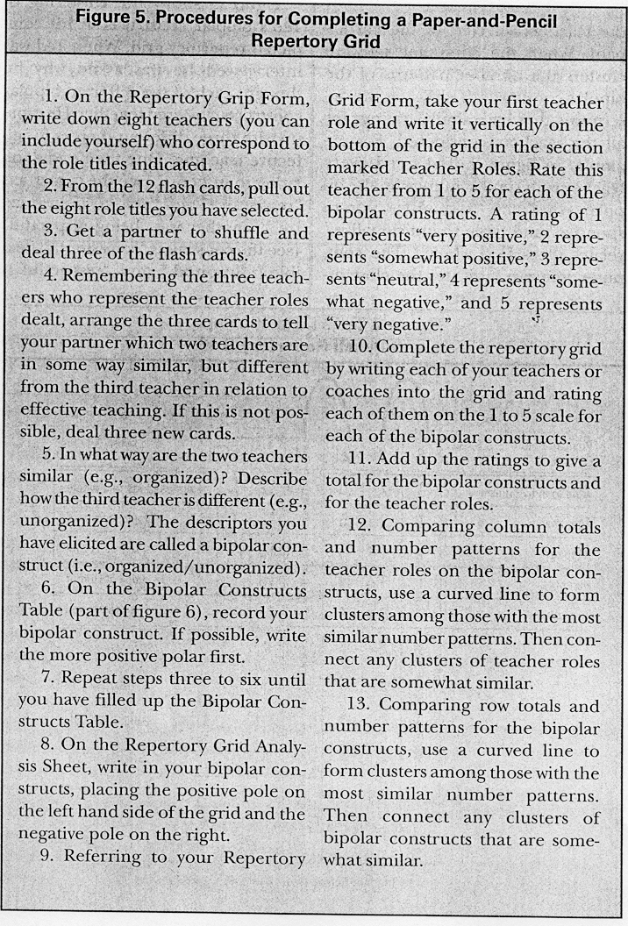

and the final theme was "energy" (see the construct "energetic"). Such themes then became "thought objects" for Ted when he reflected on his teaching. Ted was re-interviewed after he completed his field experience. In this interview, Ted explained how his "thought objects" had connected to his practice as a teacher. The next section highlights two critical incidents drawn from Ted's case study. These incidents show how Ted connected his "thought objects" to his experience of being a teacher.
Critical Incident from Ted's Experience as a Preservice Teacher
In Ted's practice-teaching class there was a large pupil, Michael, who was notorious as the city's under-IS wrestling champion. Michael was often suspended from the school for being aggressive. Ted told me the story of how Michael first approached him:
"Mark tells me you coach football." Just the way Michael said it, I thought, "He is checking me out." Enthusiastically I said, "Yeah, I do, I coach at AI.. high school.
56
Do you know the school?"
"What do you coach?" Michael asked. "I coach defense, defense. ..AAA!
You know it's hard and tough and. .." I made the actions. "You know you punch people and hit them and stuff. Work as a team." I did not give him a chance to think anything but "oh my good-ness. ..wow!"
That is the way he checked me out. He did not do it in the classroom; he did it in the hall. Then I reckon he walked away thinking, 'Yeah, he's all right.'
I never had a problem with Michael. There was one time when he was getting a bit rowdy with Cody. I said quietly, "Michael, I need your help. The kids in this class really respect you. They see you fooling around and stuff-it makes it really tough on me. I know you would not want to do that on purpose. I would not do it to you. You know that, right?"
Michael replied, "Yeah. Okay, Mr. Franks, no problem."
When Cody started fooling around again, Michael slammed his big fist on the table, grunting, "No!"
Thought Objects Connected to Incident One
As Ted explained, "I just extended the relationship that I felt I had with Michael. I felt I could go to him, be that forward, be that honest with him. I treated him like a 14-year-old kid who had a presence. Instead of just slam- ming down on him, I acknowledged him." The story showed how Ted was finding support in his experiences for his beliefs in the importance of "relating to students" and "being respectful" of students. This story conflicted with the advice Ted was given by his cooper- ating teacher, who told him to "be tough, then loosen up." To Ted, the tough part about teaching was being consistent and sincere in how he believed an effective teacher should be.
Critical Incident Two
In Ted's final teaching experience, he taught French as well as physical education. Ted ~ve the following account
Vol. 70 No.7. JOPERD .September 1999
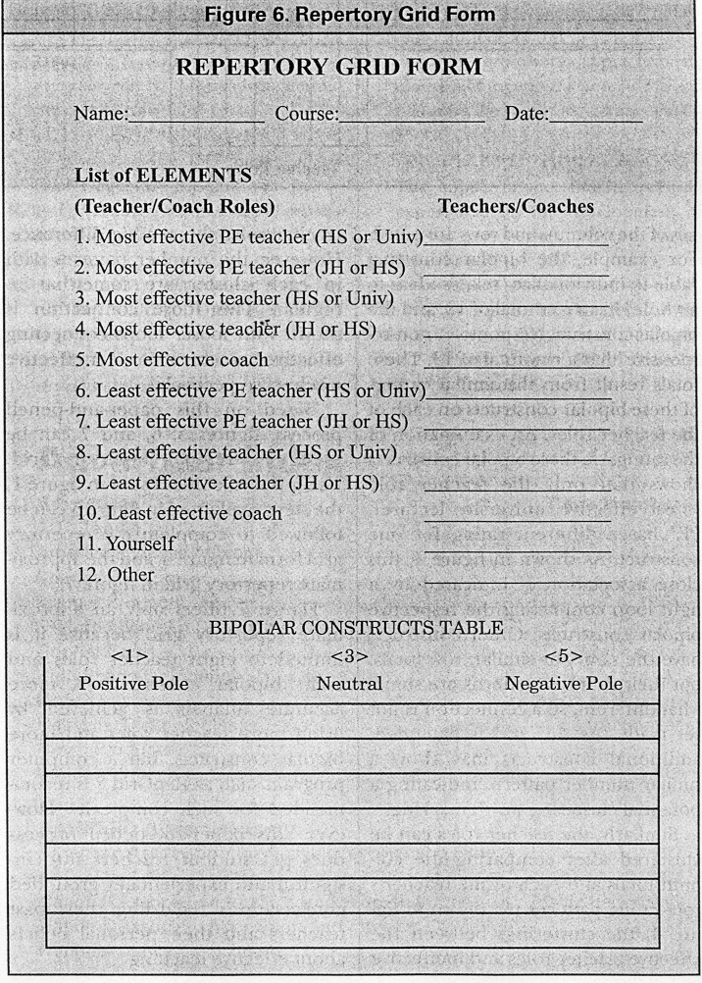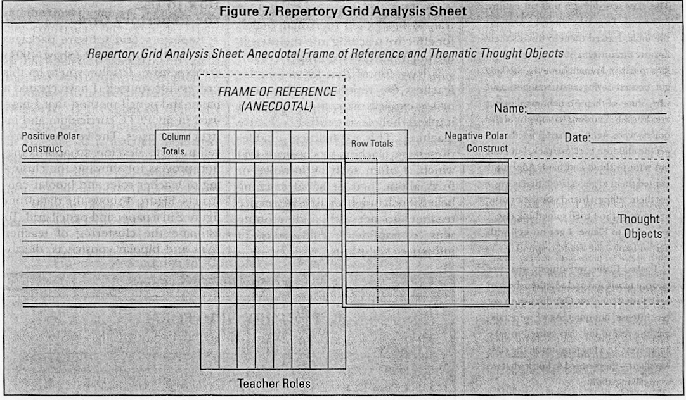

The class was doing a unit on culture and music. To get the kids excited about the topic, I asked them to discuss their favorite music with a friend. I wanted the kids to talk in French; however, the kids got excited saying what was best and why. Some of their French was slipping into English. The door was open and the noise was rising. I realized I needed to get the children back on track, but I did not want to shout and bawl. After all, I wanted them to get excited; that is why I got them telling a friend why their music was so good. So I tried something else. I went over to Elaine. I got on well with her, so I knew she would respond.
I asked Elaine very quietly what her favorite music was and whether she had been to any concerts. Our discussion got very intense, but quiet. As we were talk- ing, the rest of the class started to take an interest. In a few minutes all the class was silent-they wanted to know what we were talking about.
Thought Objects Connected to Incident Two
Ted's alternative strategy to shouting to get control had worked. The class was excited and interested in the topic-they were energized. There was no need to control them, just to channel their energy. Ted's sense of energy when learning had evolved to a sense of group energy from the class that he, as the teacher, not only ignites but also draws from.
Ted was asked how he had come up with this strategy. Ted said, "I had a sense that shouting was wrong, disre- spectful; 1 had made them excited. 1 needed an alternative strategy. 1 knew Elaine would respond." This story highligh ts again how Ted transformed his "thought objects" ("relating to stu- dents," "being respectful," and "en- ergy") into effective teaching practice.
Description of Data Source
Ted's case study was taken from a two-year study of preservice teachers completing their final years of a teacher-preparation program. For more detailed analysis of how Ted
September 1999 .JOPERD .Vol. 70 No.7
and five other student teachers transformed their personal beliefs for effective teaching into their teaching practice, refer to Hopper (1996).
I have found that for preservice teachers the repertory grid process makes explicit many aspects of their implicit beliefs regarding effective teaching. This explicitness enables preservice teachers to construe that which is often seen as intuitive or fuzzy about their personal teaching beliefs. Such insight enables preservice teachers to act with a developing sense of confidence and a sense of influence over events.
How to Use
the Repertory Grid
Repertory grid software packages such as the RepGrid 2 (Shaw, 1991) are expensive. To allow you to try this process for yourself, I have created a paper-and-pencil method that I have used in my PETE curriculum and instruction classes. The key to this procedure is to develop an approximation process for showing the clustering of teacher roles and bipolar constructs. Figure 4 shows the data from figure 2 ina paper-and-pencil grid. To estimate the clustering of teacher roles and bipolar constructs, the to-
~l

ta1s of the columns and rows are noted. For example, the bipolar construct "able to individualize/relates ideas to I a whole" has a row total of 12, and the bipolar construct "responsive/ non-responsive" has a row total of 13. These totals result from the similar ratings of these bipolar constructs on each of the teacher roles. An examination of the ratings on these bipolar constructs shows that only the teacher role "most effective university lecturer, PE" has a different rating for one construct. As shown in figure 4, this close association is indicated by a tight loop connecting the respective bipolar constructs. Other constructs have the same, or similar, row totals, but their number patterns are somewhat different, so a connection is not yet made. As the grid is extended, additional constructs may show a similar number pattern, indicating a potential clustering worth marking.
Similarly, the teacher roles can be clustered after comparing the column totals and each of the teacher's role rating patterns. As shown in figure 4, the clusterings between the effective teacher roles and ineffective
58
teacher roles shows a big difference. However, the number patterns with in each cluster are somewhat irregular. This loose connection is shown with looser loops connecting effective teachers and ineffective teachers respectively.
Based on this paper-and-pencil process, figures 5, 6, and 7 can be used to develop a repertory grid. Using the role tides listed in figure 1, the steps explained in figure 5 can be followed to complete the repertory grid form in figure 6, and the approxi- mate repertory grid in figure 7.
Figure 7 offers only an approximate repertory grid because it is limited to eight teacher roles and eight bipolar constructs. A more accurate analysis is achieved by using more teacher roles and more bipolar constructs, but a computer program such as RepGrid 2 is recommended for such complexity. However, this paper-and-pencil process does get student teachers into insightful and experientially grounded conversations regarding their past teachers and their personal beliefs about effective teaching.
The following questions can be used to analyze the grid to learn a person's frame of reference for effective teaching:
.Which clusters of two or more coaches/teachers received similar rating patterns?
.What do you think about them? Did you like them or not? Why?
.What do these teachers tell you about the attributes you value in coaches/teachers?
.What made one teacher/coach or a group of teachers/coaches different from the others?
The next set of questions can be used as a means of analyzing a person's thought objects (implicit beliefs) for effective teaching in physical education:
.Which bipolar constructs seem closely related?
.How do you think these bipolar- constructs are related?
.What themes for teaching are these bipolar constructs referring to?
.Why are these themes important to you?
.Compare your construct themes (beliefs about effective teachers) to
Vol. 70 No.7. JUl'tRD .September 1999

your partner's. How are they similar and different?
What do your partner's beliefs tell you about his or her views regarding effective teaching in physical education?
Conclusion
The repertory grid process enables student teachers to create a distance between their sense of self and their developing understanding of teaching. Another study, Rossi (1997), has also
reported the successful use of the I repertory grid with PETE students. !
This study focused on knowledge development with physical education students. Instead of using teacher roles, Rossi's study used professional terms such as "biomechanics" and "growth and development" to discover how students were interpreting, connecting, and applying the knowledge these terms
implied in their teaching practice. I Researchers have highlighted how:
the repertory grid also can be used very successfully as part of a teacher inservice (Diamond, 1991; Hunt, 1987). These researchers report that the repertory grid conversation helps teachers to research themselves as they strive to realize their teaching philosophies in practice.
The grid offers an important tool in the reflective-practitioner movement in PETE and teacher inservice. Siedentop and Locke (1997) comment that teacher education has failed
because it is built on an individual- entrepreneur model. This model assumes that "inadequate school programs will be transformed by PETE indirectly, through the influence of good graduates" (p. 26). They suggest that we need graduates taught in model physical education programs that show what is possible. Though the entrepreneur model is ineffective on its own, we still need to prepare graduates who can see what is important in model physical education programs. We need graduates who can take leadership from a thoughtful, well constructed, personal belief structure for effective teaching. Such graduates would be well prepared to
September 1999. JOPERD .Vol. 70 No.7
articulate and demonstrate their beliefs about effective teaching in physical education. Such graduates, collaborating with more experienced colleagues, could then generate and enact an effective and coherent departmental philosophy for physical education at the school and at the university.
References
Britzman, D. (1991). Practice makes practice: A critical study of learning to teach. Albany: State University of New York Press.
Diamond, C. (1991). Teacher education as transformation. Philadelphia: Open
University Press.
Hopper, T. F. (1996). Subjective knowing, personal construct psychology and teacher education: Teaching to learn in physical education. Ph.D. dissertation, University of Alberta.
Hunt, D. (1987). Beginning with ourselves: In practice, theory, and human affairs. Cambridge, MA: Brookline Books.
Kelly, G. (1955). The psychology ofPersonal constructs, Vol. I. New York: W. W. Norton.
Lortie, D. (1975). Schoolteacher: A sociologi- cal study. Chicago: University of Chi- cago Press. .r
Pope, M., & Keen, T. (1981). Personal con- struct psychology and education. London:
Academic Press.
Rossi, T. (1997). Seeing it differently: Physical education, teacher education and the possibilities of personal construct psychology. Sport, Education and Society, 2(2),205-221.
Schon, D. (1983). The reflective practitioner. London: Temple Smith.
Schon, D. (1987). Educating the reflective practitioner: Toward a new dRsign for teach- ing and learning in the professions. San Francisco: J ossey-Bass.
Shaw, M. (1991). RepGrid2. Available from Mildred Shaw at Centre for Personal Computer Studies" 3019 Underhill Drive NW, University of Calgary, Calgary, Alberta, Canada T2N 4E4.
Siedentop, D., & Locke, L. (1997). Mak- ing a difference for physical educa- tion: What professors and practitioners must build together. Journal of Physical Education,Recreation & Dance, 68(4),
25-33.
Tabachnick, B., & Zeichner,K. (1984). The impact of the student teaching experience on the development of teacher perspectives. Journal of Teacher Education, 35(6),28-36.
Tim Hopper is an assistant professor in the School of Physical Education at the Univer- sity of Victoria, Victoria, British Columbia V8W3Pl, Canada.
59

